**Name of student:** 賴冠維

**Student ID: 108071601**

* **Title of the paper:** Commitment versus Flexibility and Sticky Prices: Evidence from Life Insurance
  + Main research question

1. Pricing behavior of long-term financial services underexplored
2. Price dynamics crucial for understanding effects of macro policies
3. How financial shocks transmit to households through insurance prices
   * Motivation
4. Life insurance premiums is so rigid that rarely change in years.
5. Premium adjustments are sizable and the policyholder have a tremendous cost to change insurers.
6. Life insurance at far right tail of the distribution of price changes
   * Economic justification

This study found that the volatility of life insurance changes over time, with a monthly variation coefficient of 6.3%, while the average absolute monthly variation is 1.4% of the average.

However, the overall probability of monthly premium changes in the data is only 2.6%, which means that the average premium period is about 39 months, and some products have maintained a constant premium for more than 20 years!

This paper’s empirical findings indicate that life insurance companies tend to maintain a stable premium for age. This means that throughout the life cycle, young policyholders may maintain the habit of paying until they are old.

* + Empirical results
    - Sample:
    - Time Span：May 1990 - October 2013
    - Site：Compulife Software 5 year to 20 year renewable policy

(Total of 234 companies, with 578 different products)

Methodology:

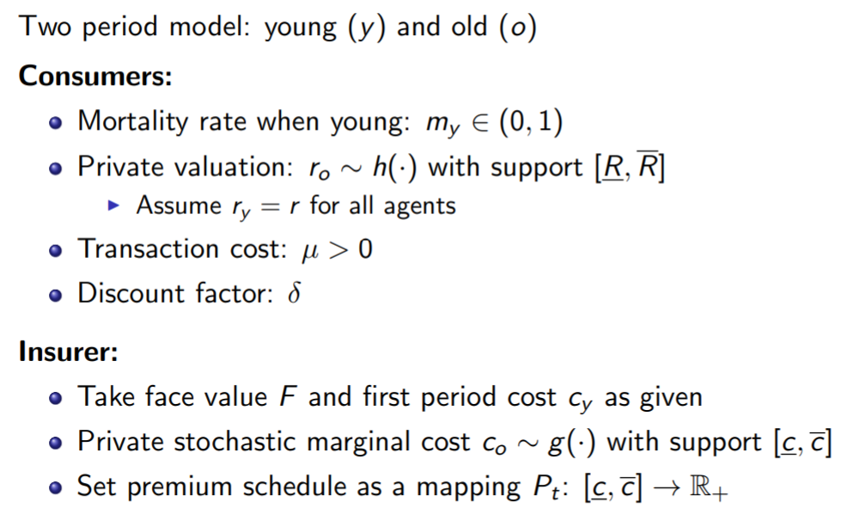

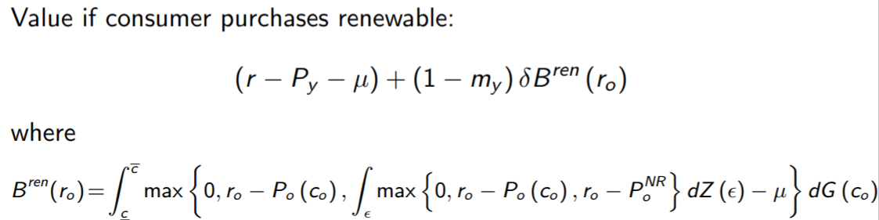

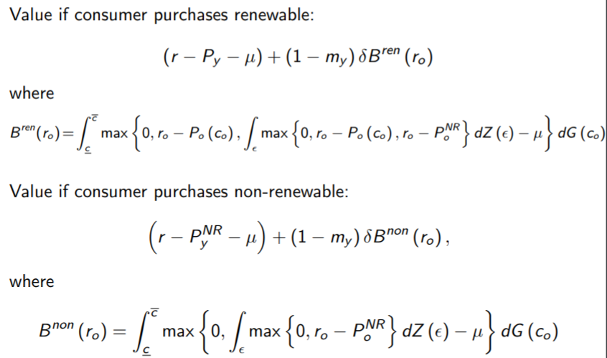

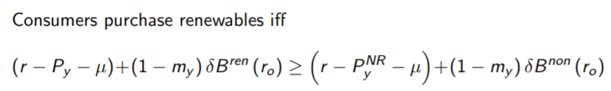

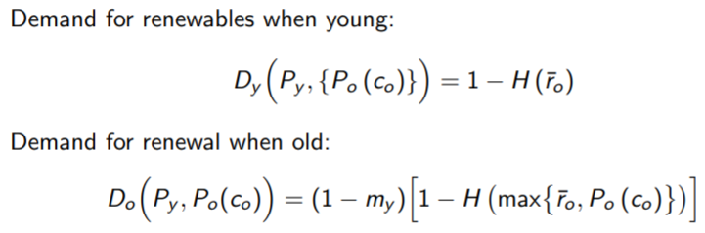

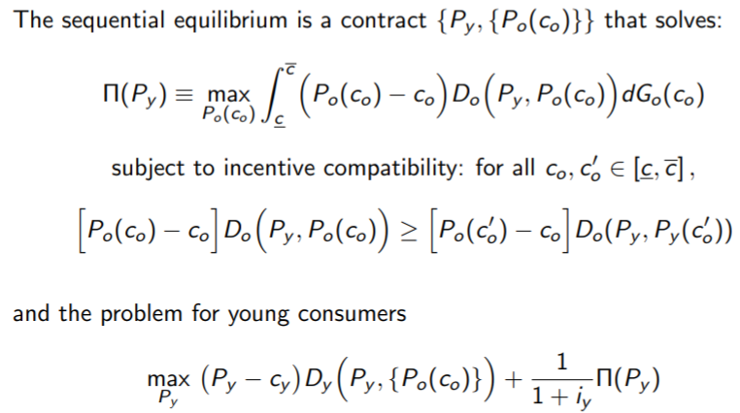

* + - Main empirical findings

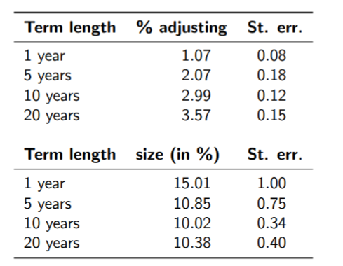

We found that as the data originally observed,the probability of premium changes is very low, but if there is a change, the magnitude of the change is extremely large.

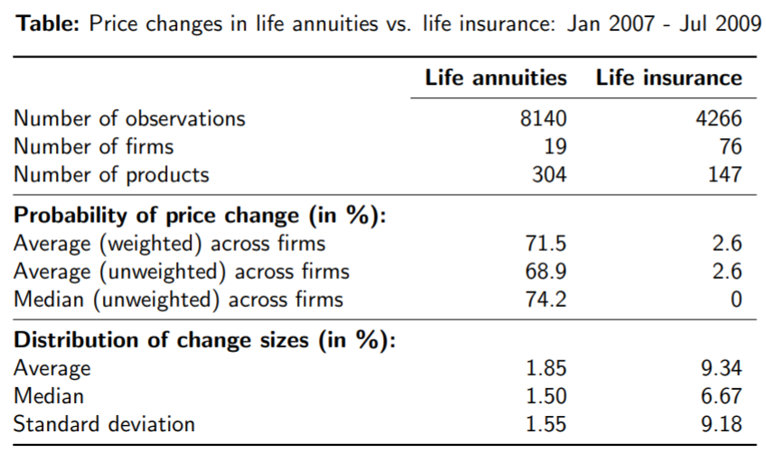

We have also found that compared with renewable life insurance, the frequency of changes in the lump-sum annuity is not as rigid as life insurance, and the range of changes is not as drastic as life insurance.

* + Future research:

For this kind of theory on the rigidity of life insurance prices, there is still a lack of relevant policy implications. If it can be extended to the policy level, it is expected to have a further impact on American life insurance.

* **Reflection:**

Regarding this research on the price rigidity of renewable term life insurance in the United States, I have the following thoughts and experiences:

Regarding the data discovery part, the author found that all the premiums paid by the policyholders were calculated, and the pure premiums payable by the policyholders during the accumulation period can also be understood. The resulting fluctuation range is very sharp. As far as I understand, the life insurance company is in the pure The premium is also charged with additional fees, and it is regarded as the same risk-bearing group according to the holder of the policy, and the death rate of the group is estimated according to the policyholder group. If the life insurance company originally sold this policy, it would use guaranteed renewal When the actuaries estimate the premium, they have considered the possibility of the insured’s physical condition changing when the contract is renewed. Otherwise, the insurance company will also sell non-guaranteed renewal policies.

And why the premium changes are so rigid, the reason may come from, normally if the premium is calculated based on the mortality rate, the older the person, the higher the premium should be paid, but this is not in line with the situation of our work income, so it is very big Most life insurance adopts leveled premiums. The premiums paid when you are young are paid in advance, while the premiums paid when you are older are actually less than the pure premiums, which may lead to rigidity in the premiums.

As for the mortality rate, the author uses the mortality rate announced by the government to calculate the mortality rate. When estimating the mortality rate, the life insurance company estimates the mortality rate based on the insured’s physical condition and health examination data. Therefore, the mortality rate is normal. It is said that it should be lower than the overall, and the final discounted interest rate should be long-term rather than short-term. Each life insurance policy is similar to a forward contract. Depending on the conditions of both parties, each policy is different, not the same as general financial The commodity is a standardized product, and only needs to consider the death of the insured, the withdrawal, or the return of the accumulated maturity, and it is not appropriate to discount the short-term interest rate.